CSO Coalition Interventions

District-level Quarterly Reporting

1. Background Information
Reporting Quarter: | August - October 2024
Reporting District: | Bombali
Report Compiled by: | Lansana Mansaray (Coalition Secretary, Bombali District)
Report Reviewed and Finalized by : | Madam Betty Alimamy Sesay (Coalition Chairperson, Bombali District)
Report Submission Date: | xxxx

2. Personnel and Operations
Headlings | Descriptions
2.1 Staff and other personnel | Please indicate the personnel (including consultants), who have been involved in the intervention voluntarily or paid during the reporting period, and their specific roles.  Personnel involved in the advocacy toolkit training and validation included staff from UNDP, a representative from the Women Peace and Security (WPS) Coalition national executive, and 20 (10 each) WPS district coalition members from Bombali and Karene districts. The UNDP staff facilitated the training and validation, supported by the national executive representative, while the district coalition members participated as trainees/participants.  In commemoration of the 25th anniversary of UNSCR 1325 (2000), The activity involved personnel from UN Women and 64 chairpersons (18-35: 37 and above 36: 24) across the six coalition district chapters (Bombali, Karene, Kono, Pujehun, Western Area Urban, and Western Area Rural districts). UN Women organised and facilitated the engagement, while the districts coalition chairpersons were involved as participants in the anniversary.
2.2. Equipment | Please indicate the status of the equipment for the coalition, any new purchases / donations for the reporting period, as relevant. If there are no changes from the previous reporting period, please duplicate the information  xxxxxxxxx
2.3 Others | Any other  Xxxxxxxxx

3. Report on Activities / Milestones Achieved
No/# | Activity Planned | Status (Completed, In-progress, Not-started) | Description of Progress  Include relevant info; total reach, locations, contributions, why
1 | To promote peace and unity in the community in celebration of International Peace Day, fostering awareness about the importance of peaceful coexistence. | completed | On the 30th September 2024, the women peace and security coalition Bombali in collaboration with Womens Forum for Human Right and Democracy Sierra Leone organized a peace walk in celebration of peace day. The peace walk commenced at the Makeni clock tower at around 7:00 am, gathering over 300 participants from diverse backgrounds, including the police, civil society organizations, local residents, community leaders, and peace organizations. The event began with a welcome speech by the LUC Sierra Leone police, followed by a statement from the coordinator womens forum for human right and democracy emphasizing the significance of peace in our society.  Participants walked from clock tower to pastoral center taking into account different routes stopping at significant landmarks to reflect on messages of peace.  Along the route, stations featured Information on peace-building initiatives, Stories from local peace advocates etc.
2 | Training on Advocacy Toolkit | Completed | On October 2, 2024, UNDP, in collaboration with UN Women and World Vision, successfully conducted a one-day Advocacy Toolkit training at the L & J Hotel, Magbenteh, Makeni. The workshop aimed to enhance the advocacy capacity of the Women Peace and Security Coalition (WPSC) members, reaching a total of 20 participants (10 each) from the Bombali and Karene chapters.  The training was highly interactive, featuring practical group exercises that facilitated experiential learning. Participants gained valuable insights into various advocacy processes and tools, such as identifying issues, selecting targets, developing key messages, and utilizing media. The workshop concluded with field tests and a feedback session, providing clear insights into effective practices and areas for improvement.  This training was follow-up by validation exercise conducted on October 17, 2024, at MADAMs conference hall at Makambo, Makeni. The activity included participants from all WPSC district chapters (Bombali, Karene, Pujehun, Kono, Western Area Urban, and Western Area Rural districts). Through practical participatory sessions, the outcome of the initial advocacy toolkit training was further discussed, and the tool was evaluated and finalized for use by all WPSC chapters and, by extension, their respective civil society organizations as needed. This process will be fully completed or achieved after the final compilation and sharing of the tool by UNDP.  The above actions significantly contributed to building the advocacy skills of WPSC members, empowering them to effectively address and advocate for womens peace and security issues in their respective districts.
3. | Assessing progress and weaknesses in view of the commemoration of the 25th anniversary of UNSCR 1325 (2000) | Completed | The 25th anniversary of United Nations Security Council Resolution (UNSCR) 1325, adopted in 2000, was held in Freetown. This event marks a significant milestone in the Women, Peace, and Security (WPS) agenda. This resolution was groundbreaking as it was the first to address the disproportionate impact of armed conflict on women and the importance of womens involvement in peace processes.  In recent years, the security situation in the West Africa and Sahel regions has deteriorated significantly due to successive military coups in countries such as Mali and Guinea. These coups have led to immediate economic, political, and military sanctions imposed by ECOWAS and the West African Economic and Monetary Union (WAEMU). The combination of economic sanctions, natural disasters (such as mudslides, droughts, and floods), and worsening security and political instability has had severe consequences on the local population, particularly affecting women, young people, and children. These groups face increased costs of living, lack of economic opportunities and basic services, threats of sexual and gender-based violence, and forced recruitment.  In some Sahel countries, civic space and freedom of expression are increasingly restricted by authorities under the guise of security measures. For instance, in Guinea, the prime minister has suggested extending the transition period until the end of 2025. At the national level, political party allegiances are marked by tensions within countries and regionally between neighbouring countries. Globally, the security and political situations in the Sahel remain unstable, volatile, fragile, and uncertain. Despite these challenges, womens roles and presence in transition institutions and processes are often invisible, non-existent, or highly limited.  Ahead of the 20th anniversary of UNSCR 1325 in 2020, the United Nations Office for West Africa and the Sahel (UNOWAS), together with ECOWAS, conducted an impact assessment and analysis. This assessment showed that some progress has been made and positive results achieved in terms of women, peace, and security. However, there is still a long way to go to achieve better results, especially given the current global realities and threats. The assessment particularly highlighted progress in conflict prevention and management, as well as in the promotion of peace involving women.

4. Program Results
Guidance: Provide a narrative in this space on any significant outcomes/changes as a result of the coalition intervention in your district of operation
Following the Advocacy Toolkit training on October 2, 2024, significant outcomes have been observed in Bombali district. The training empowered the WPSC members with enhanced advocacy skills, which will contribute to more effective and strategic advocacy efforts within the district. These include:
- Enhanced Understanding of Community-Centered Approach to Advocacy: Participants now have the understanding that this approach involves supporting and enabling marginalised and voiceless individuals to have their voices heard and respected.
- Increased Participants Understanding of Advocacy Processes/Approaches: Participants gained a deeper understanding of effective advocacy strategies and processes.
- Practiced the Development of Theory of Change: Participants were divided into small groups to develop a theory of change, following the steps taught during the one-day workshop, which has enhanced their understanding.
- Increased Participants Awareness: There was a significant increase in participants awareness of the importance of advocacy and the availability of relevant tools to support these efforts.
- Networking Opportunities: Additionally, the training fostered better collaboration and networking among coalition members, enhancing their collective capacity to address local challenges through supportive efforts of future advocacy initiatives.
- A WhatsApp group was established for easy communication during the open day.
- The event facilitated networking and collaboration, allowing participants from different countries to connect and brainstorm ideas for joint events independently of UNOWAS.
- Recommendations from the event are to be submitted immediately to each countrys working group and then forwarded to UNOWAS in Dakar.
- Participants gained a better understanding of women in peace and security from various country perspectives, enhancing their knowledge of womens roles in peace building, advocacy, and lobbying.

Overall, the intervention has significantly strengthened the WPSCs capacity and role in advocating for womens rights and security in Bombali district, thereby contributing to positive social change and community empowerment. Additionally, the 20th anniversary of UNSCR 1325 in 2020 enhanced the knowledge of WPSC district chapter leaders on womens roles in peace building, advocacy, and lobbying through connections and brainstorming sessions with representatives from different countries.

5. Challenges and Lessons Learnt
Documenting key challenges and lessons learnt that need to be replicated or sharing as evidence-based approach
Challenges
- Insufficient Training Days: The workshop is crucial for the coalitions advocacy efforts, as it encompasses all aspects of Women, Peace, and Security (WPS) interventions and engagements. Given the comprehensive nature of the workshop package, a single day is insufficient for thorough participant engagement and a complete understanding of the workshop/training concepts.
- Late Notification: The late notification and lack of sharing the workshop plan were also concerns, as they limited participants ability to contribute effectively to some of the topics discussed.
- Language Barrier: One participant from a Francophone country was unable to present due to a language barrier, as they could only speak Arabic and there was only an English and French interpreter available.
- Limited Participation: Only one participant presented on SWOTs on behalf of other countries, who were only asked to provide inputs, limiting the diversity of perspectives shared.

Recommendations
- To ensure a comprehensive understanding of the concept, it is recommended that the duration of future engagements of this nature be extended to at least three days.
- For future workshops, please ensure participants are notified well in advance and that the workshop plan is shared prior to the event. This will enable participants to prepare adequately and contribute meaningfully during the sessions.
- Ensure the availability of interpreters for all relevant languages, including Arabic, to facilitate better communication and participation.
- In the future, ensure to share the workshop plan and expectations well in advance, allowing participants to prepare their presentations and contributions.

Lessons Learnt
- Participants learnt that the Community-Centered Approach to Advocacy involves supporting and enabling marginalised and voiceless individuals to have their voices heard and respected.
- Participants also learnt that advocacy can be more impactful and successful when there are clearly established and effective advocacy strategies and processes to follow.
- Participants understood what a theory of change is and how to develop it.
- It was evidently clear that there was need for multilingual support by ensuring the availability of interpreters for all relevant languages. This can help overcome language barriers and facilitate better communication and participation.
- It was also learnt that encouraging broader participation by allowing more participants to present their own SWOT analyses can enrich discussions with a wider range of insights and experiences.

6. Innovations
Innovative actions used to mitigate the challenges
- Recognizing the need for more time, the organizers rescheduled a follow-up validation training to delve deeper into the initial advocacy toolkit training and address emerging questions and clarifications. This ensured that participants had ample opportunity to fully understand and collectively agree on the applicability of the toolkit in all advocacy drives of the coalition.
- The workshop incorporated highly interactive and participatory methods, such as group exercises and practical activities, to maximize engagement and learning within the limited time. This hands-on approach helped participants grasp complex concepts more quickly.
- The workshop agenda was made flexible to accommodate participants needs and interests. This allowed for adjustments based on the participants feedback and ensured that the most critical topics were thoroughly covered.
- Utilize real-time translation apps and devices that can instantly translate spoken language, allowing participants to communicate more effectively.
- Engage facilitators who are fluent in multiple languages, including Arabic, to bridge communication gaps during presentations and discussions.
- Rotate presenters through the implementation of a system where different participants take turns presenting on behalf of their countries, ensuring a wider range of voices and perspectives are heard.
- Create smaller breakout groups for SWOT analysis discussions in order to allow more participants to actively engage and present their findings within their groups.

7. Next Quarter Activity Plan
Please indicate the planned activities for the next quarter using the below table
Planning Quarter:
No/# | Planned Activity | Responsible Person | Resources Required | Target Beneficiaries | Date of Implementation

8. Pictorial Evidence
At Most 3 activity photos including photo credit
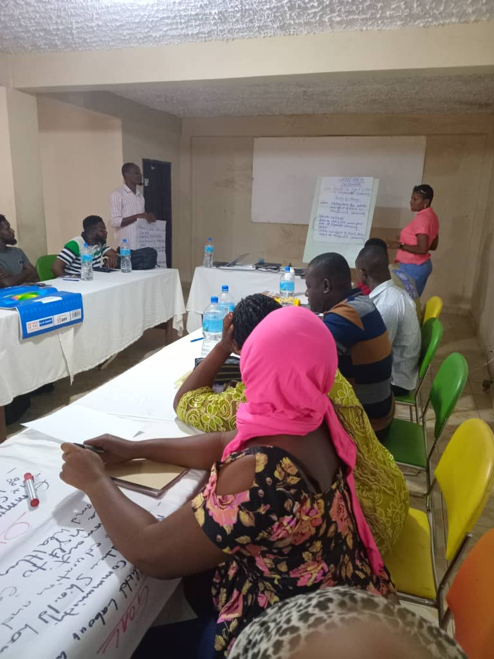
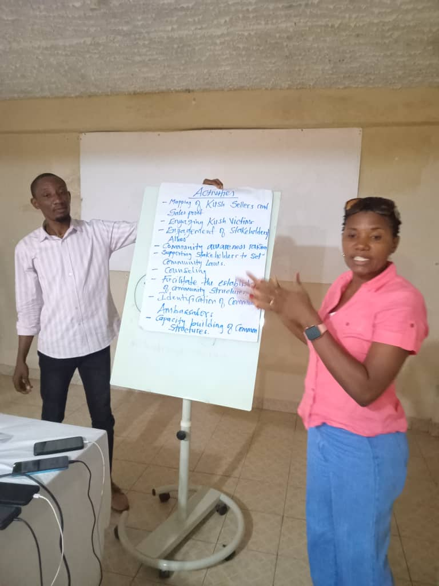
Group Presentation on the Advocacy Theory of Change

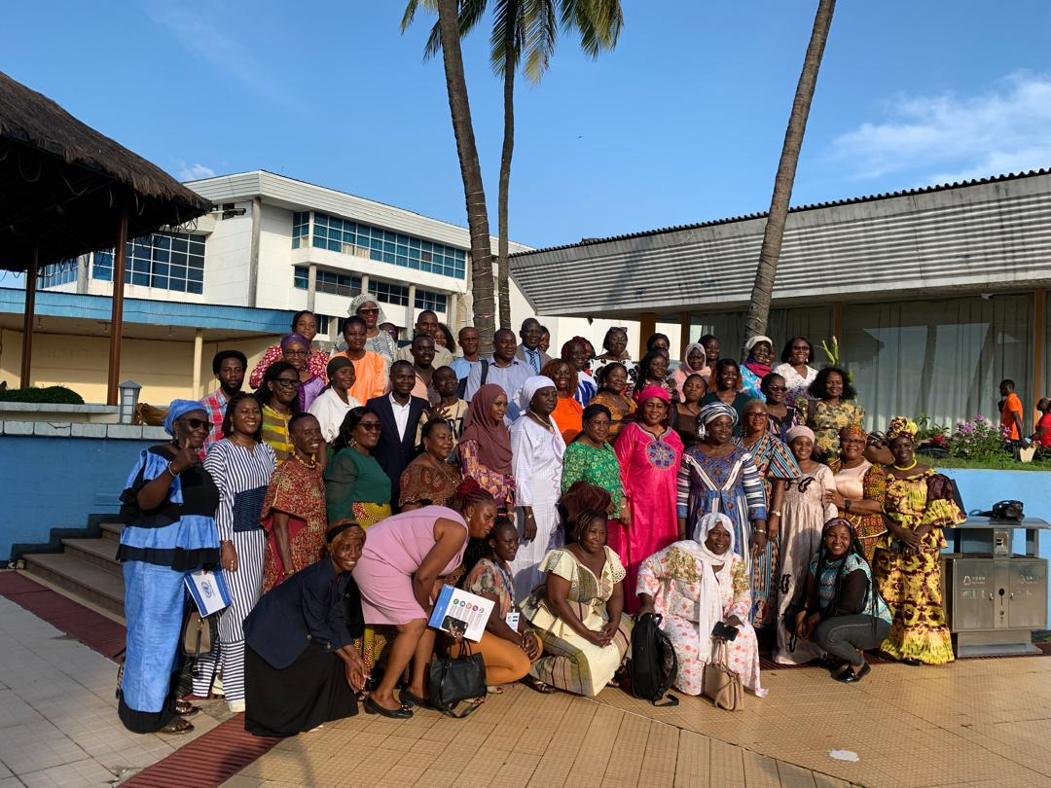
Photo of Participants of the UNSCR 1325(2000) 25th Anniversary

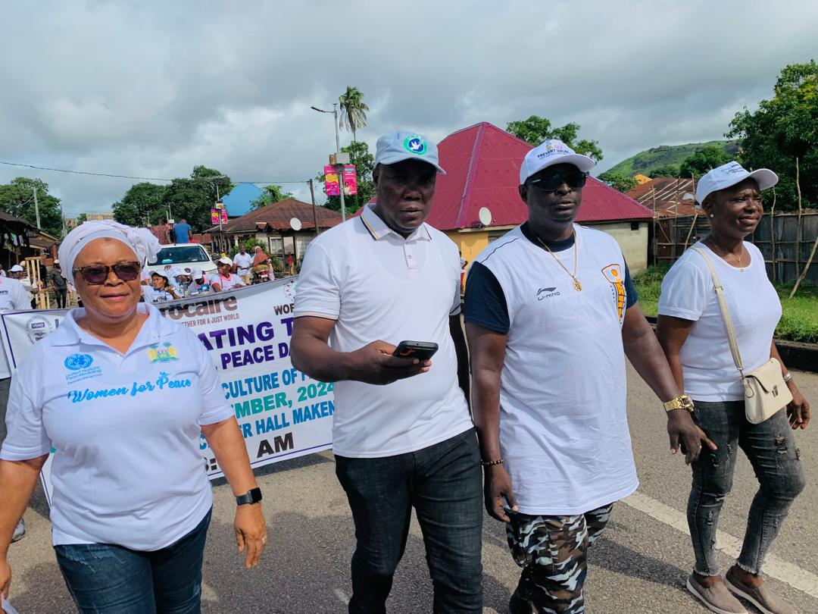

The WPS chairperson in Bombali making statement on the role of women in sustaining national peace. 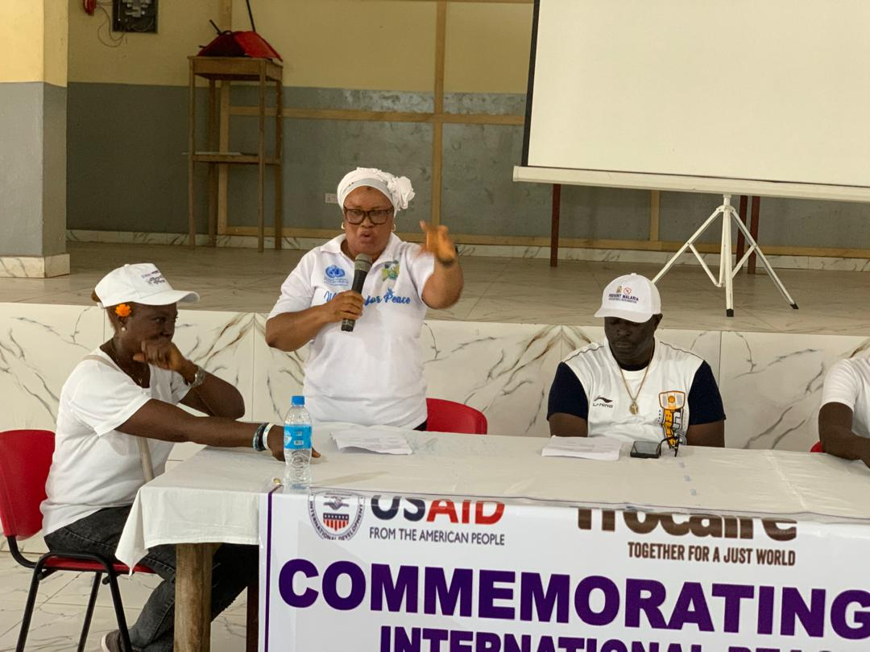
WPS chairperson Bombali, ICPNC-Bombali, LUC-Makeni and Dep. Chairperson BDHRC actively took part in the peace match to promote peace during the celebration of International Peace Day.

